C# Assignment:

Food Court Management System:





Admin can log into system:

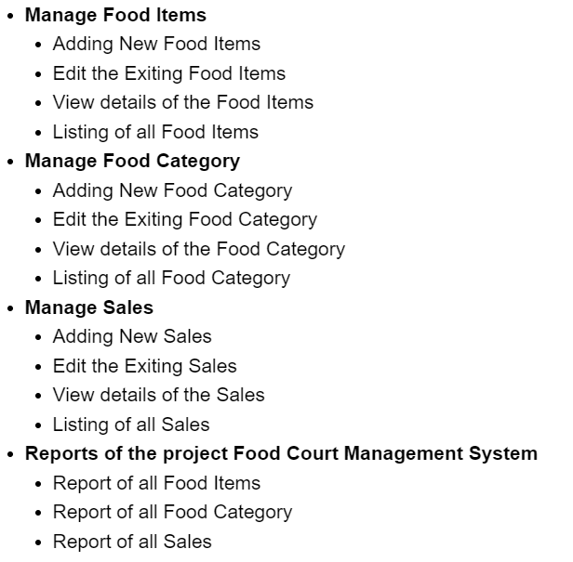

Note: You have to implement file handling or array storage to maintain data about food and sales information

Your console screen should be show 4 menu options: ManageFood,Manage Foot category, ManageSales, Reports

Based on menu selection you should show other sub menu items.

Example: If admin select Manage food items(Add new food,view fooditem,Edit footitem,listing all the food items. Like this you have to show other sub menus part of main menus.